Monday:
Facebook & Twitter:
This weekend we heard Brock Mealer’s inspiring story of overcoming his problems! Catch the #northwoodsrewind @ http://media.northwoods.church.

FB-Peoria & CH
Join us for a family night Ice Cream Social as we watch the words from the Gospel of John come alive through the talents of Keith Ferrin. Find out more at nwoods.org/peoria/events/ice-cream-social-keith-ferrin/

Tuesday:
Facebook & Twitter:
Experience freedom, healing, restoration, and recovery in Jesus Christ! Re:Generation starts tomorrow! Nwoods.org/regen
https://vimeo.com/182597971

Wednesday:
Facebook, Twitter, & Instagram:
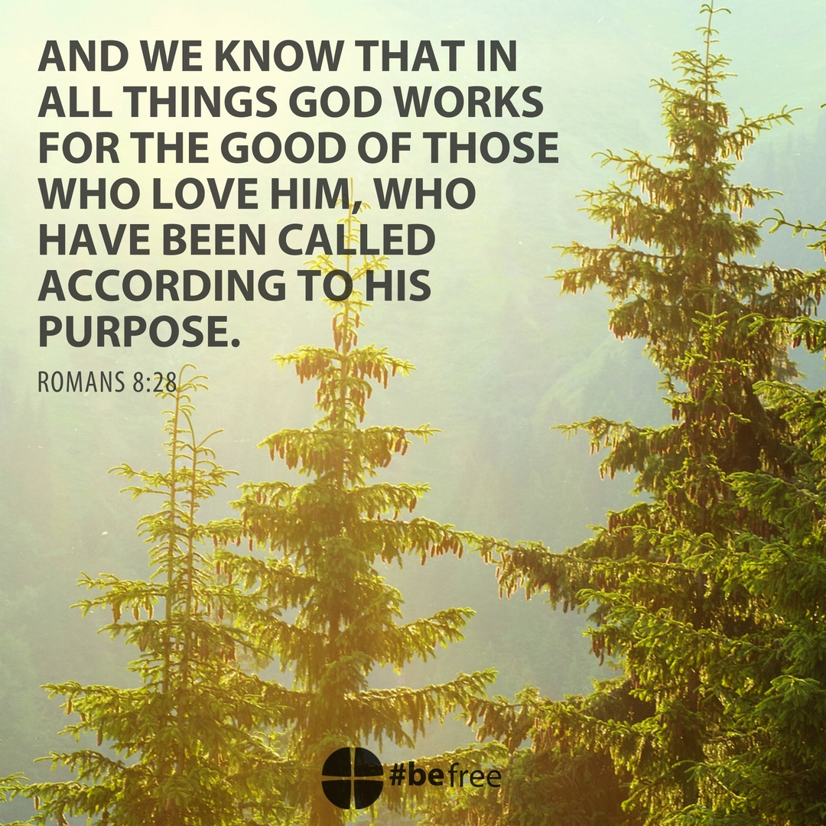
#befree

Thursday:
Twitter & Facebook:
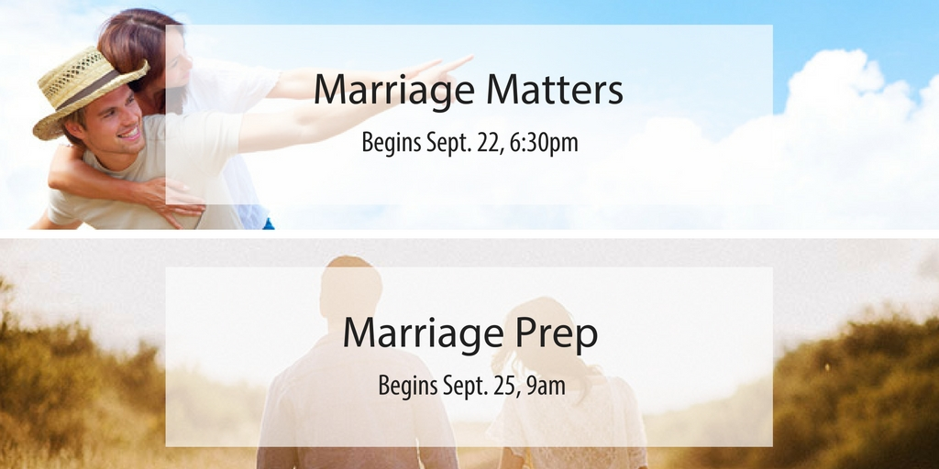
Marriage is God’s creation, His design for us to experience relational intimacy and love that mirrors the love relationship Christ has with His followers. Deepen your marriage this fall with one of these opportunities! Read more @ nwoods.org/marriage.

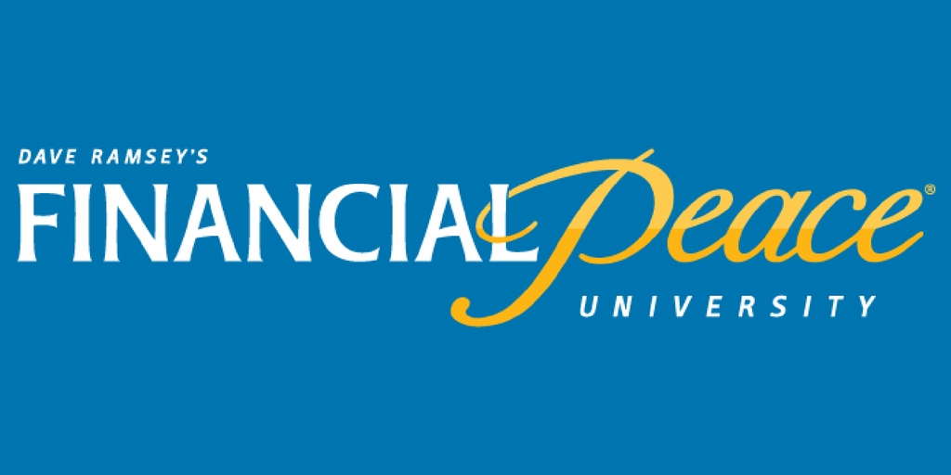
Financial Peace University begins today! Learn more @ nwoods.org/fpu

Friday:
Facebook, Twitter, & Instagram
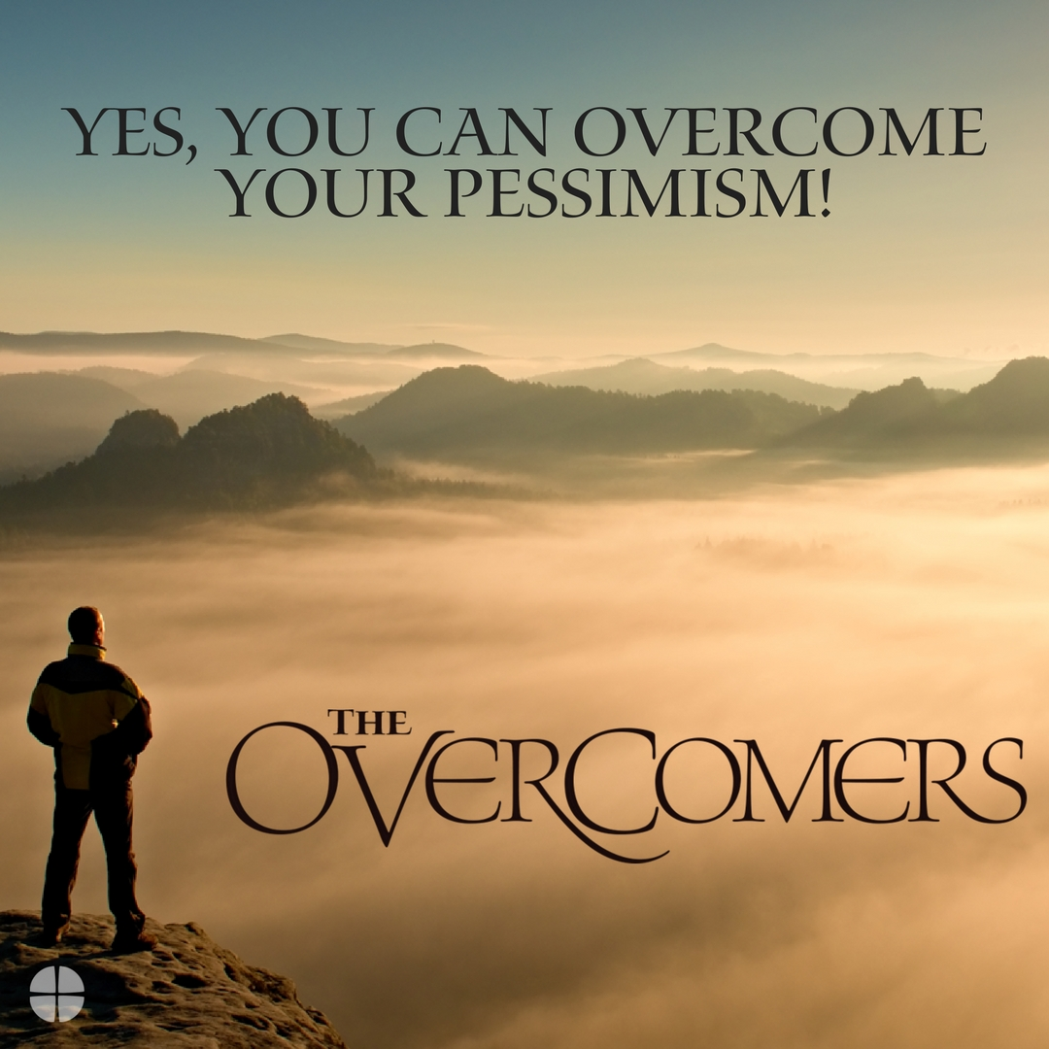
Yes, you can overcome your pessimism! Join us this weekend for The Overcomers! Nwoods.org/join-us

Saturday:
Facebook & Twitter
Join us this weekend and find out how God made you to overcome! Nwoods.org/join-us

Sunday:
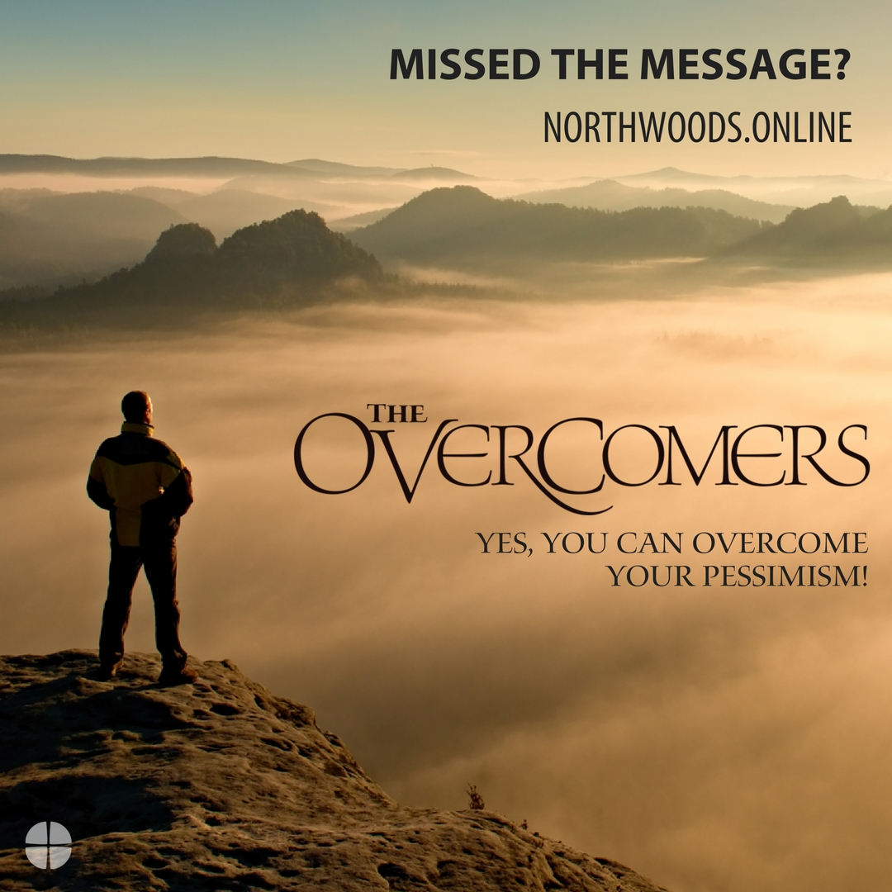
Catch the replay @ http://northwoods.online

